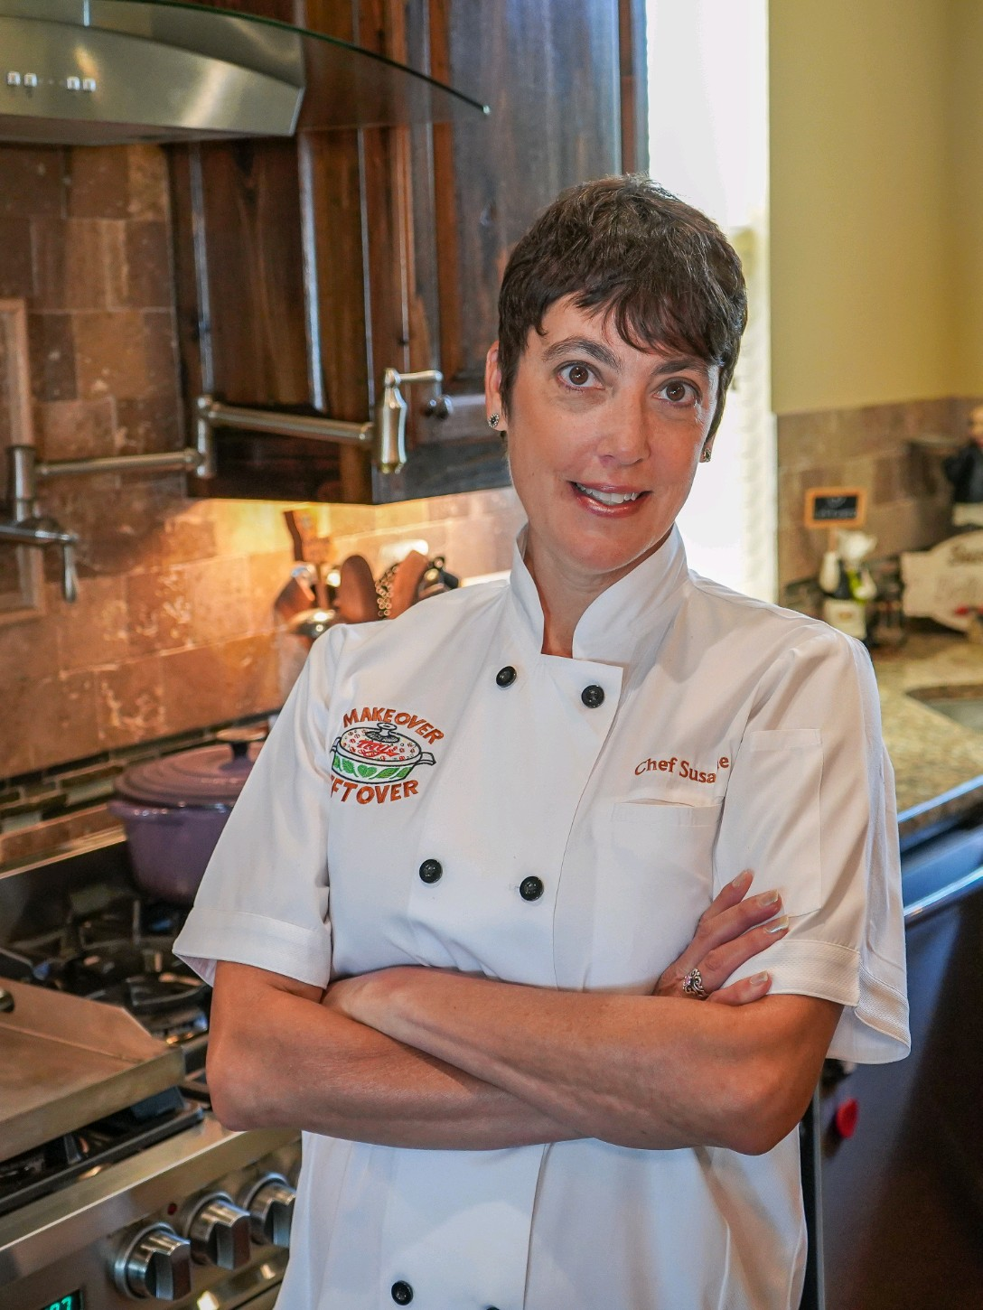

SUSANNE DUPLANTIS

CHEF/AUTHOR

www.makeovermyleftover.com

225-773-1887

susanne@makeovermyleftover.com

About the CHEF
Susanne Duplantis  Louisiana native Susanne Duplantis is an award-winning chef, restaurant veteran, and creator of the food waste blog, Makeover My Leftover. A Certified Health Education Specialist, she has competed in national and international cooking competitions and was a successful competitor at the World Food Championships and the Blended Burger Battle.  Susanne works as a recipe developer for national brands, but her passion is eliminating food waste. She conducts food waste workshops and cooking demos across the state of Louisiana and was featured in the Netflix series Best Leftovers Ever! and Food Network’s Big Bad Budget Battle. She was a guest on the Tamron Hall Show and hosted a monthly cooking segment on Baton Rouge’s CBS affiliate, WAFB for five years. She lives in New Roads, Louisiana with her husband, Chris, and her donkey, Fred. | Makeover My Leftover Official Logo  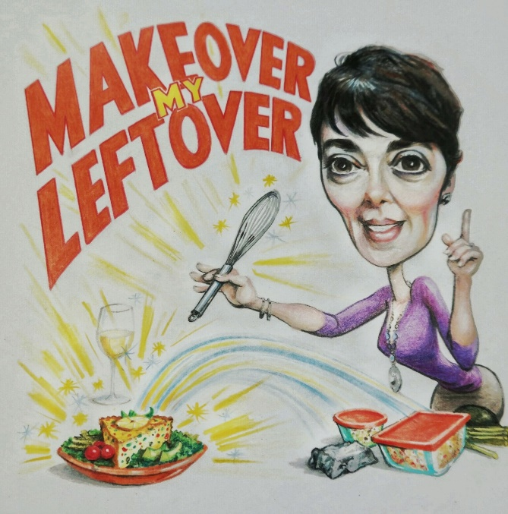
The blog, Makeover My Leftover, was created in 2015 and has an email list of 4,230 subscribers. It offers bi-monthly posts and weekly tips to help subscribers save, food, money, and time in the kitchen. It was the inspiration for Susanne’s first published cookbook, “Lagniappe Leftovers” by Pelican Publishing.

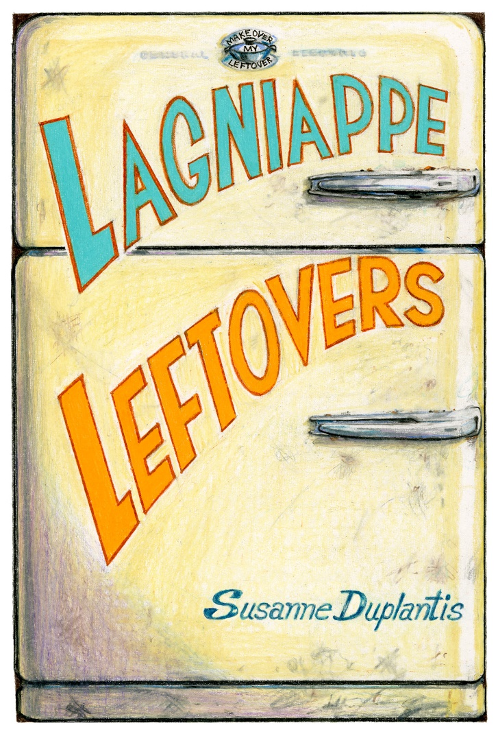

About the BOOK

Lagniappe Leftovers

“Susanne Duplantis is out to save the world one leftover at a time. You’ll think twice before ever throwing edible food away again!”
—Poppy Tooker, host of Louisiana Eats! radio show

“With this fun, family-friendly cookbook, there’s no longer any excuse for standing in front of the refrigerator with the door wide open and asking oneself the eternal question: ‘What in the world am I going to make?’”
—Adrian Miller, James Beard Award-winning author

“You’ll never look at your leftovers the same way again! Susanne Duplantis has unlocked the code to rethinking leftovers and reducing kitchen waste.”
—Cynthia Graubart, James Beard Award-winning author

Susanne Duplantis takes the last bit of leftovers from your favorite Southern dishes and repurposes them into brand-new tasty offerings. These simple home-cooked recipes combine the time-saving advantage of leftovers with the convenience of pantry staples you already have on hand to create family-pleasing meals that are also friendly on your wallet. With Susanne’s guidance, you’ll begin to see leftovers as a delicious way to save time, food, and money.

“Lagniappe Leftovers” can be found on Amazon, Barnes & Noble, Walmart, or your local bookstore

@makemyleftover
Instagram: 1,580
Twitter: 780

Makeover My Leftover
Facebook: 2900
Pinterest: 179

For bookings, cooking demos, and appearances 225-773-1887
